**Switch over test from primary and statndby database**

1. Primary database name JFSDRUAT—172.17.70.21
2. Standby database name JFSUAT—192.168.20.213

**1 Sync Status and Database Role**

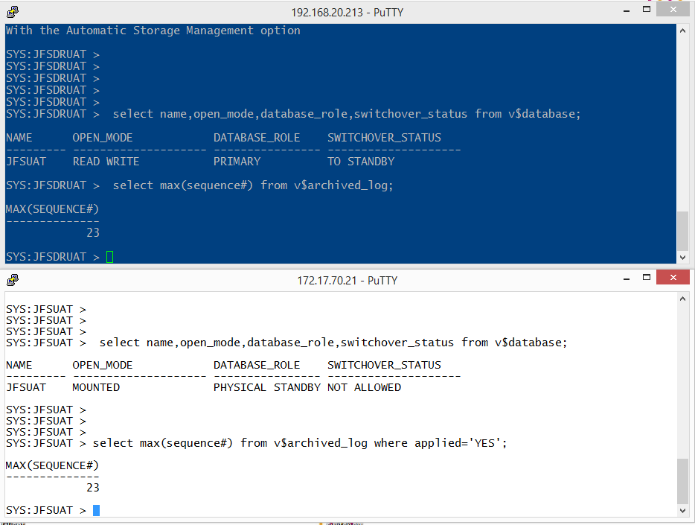

**3 Insert Values into a table in primary database;**

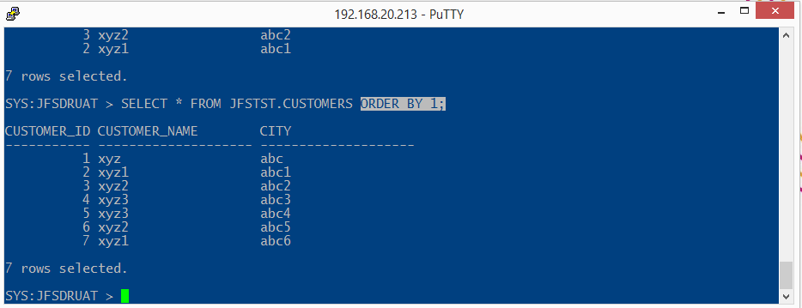

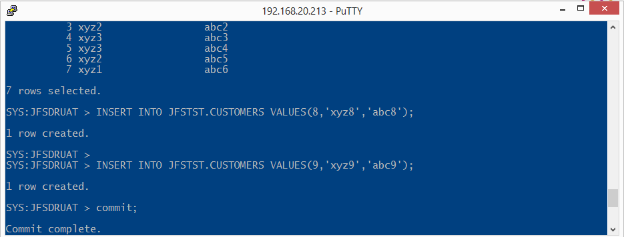

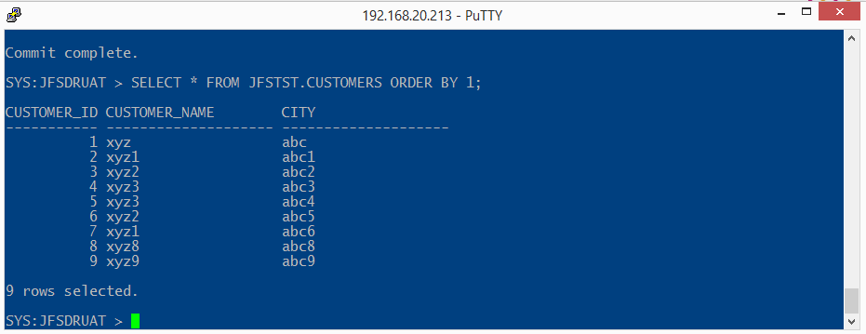

**4 Sync Status after insert value intot able :**

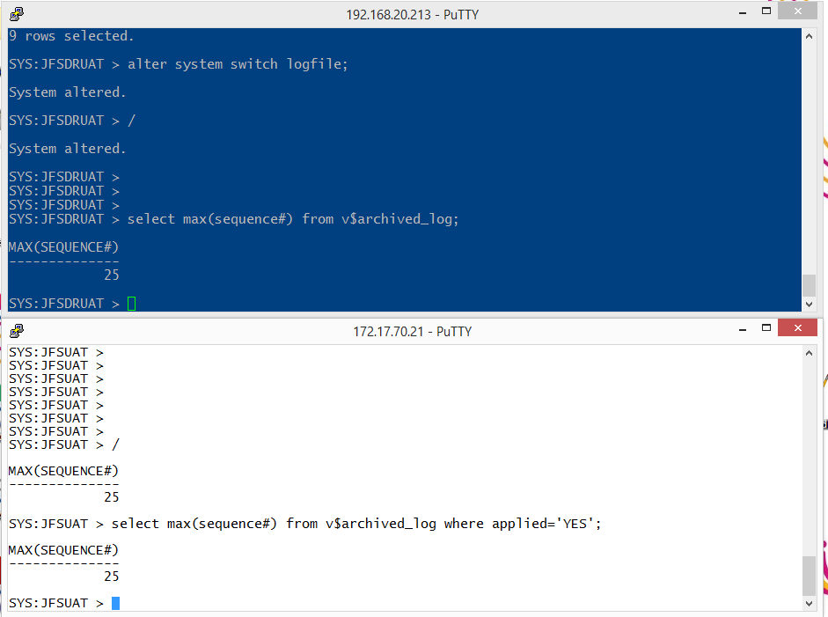

**5 Switchover Database**

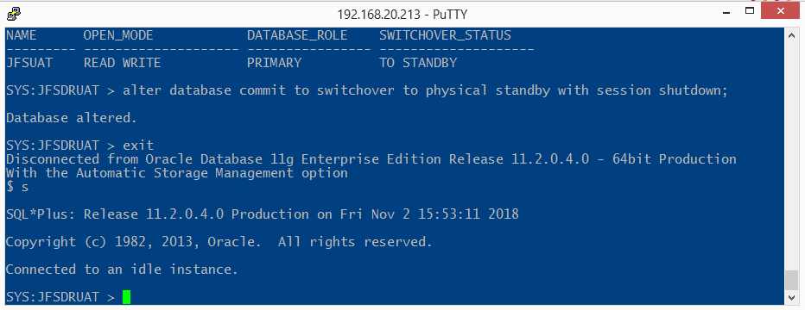

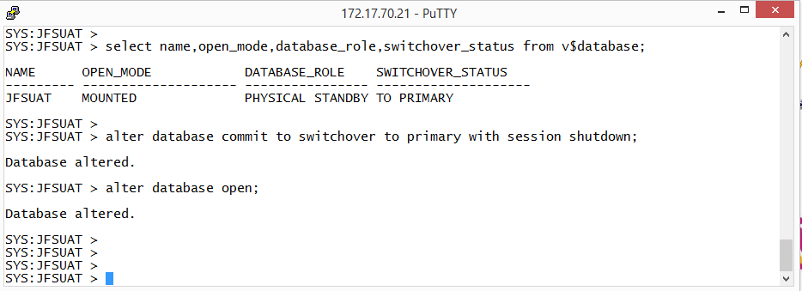

**6 Sync Status after switchover**

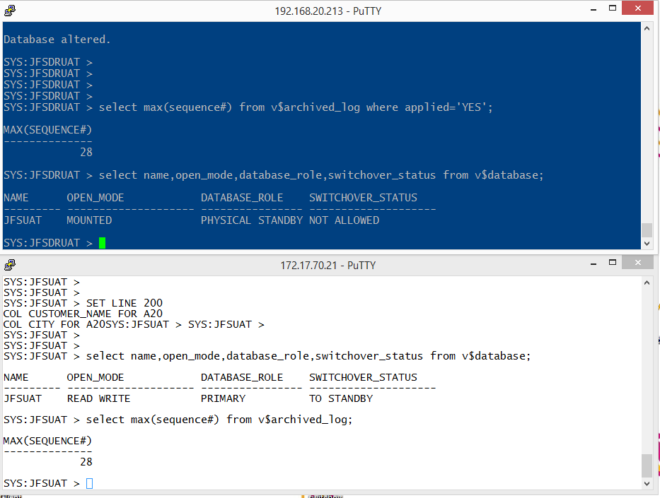

**Record In the table after switch over**

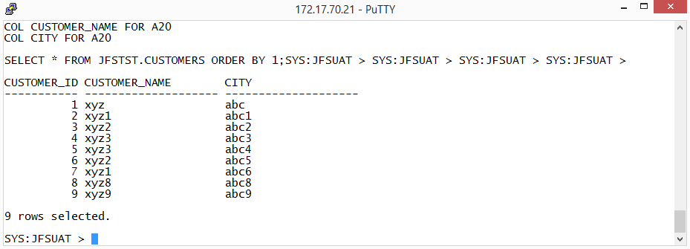

**Insert the Value into the table**

